

Dictation Solutions for the Law Enforcement Industry

Cost Effective Dictation Systems and Voice Capture

- Dictation Your law enforcement agency will be able to more
- Transcription Players effectively document, collect, manage and archive
- Dial-in Voice Servers dictated incident reports, providing a powerful tool
- Digital Handhelds to fight crime and improve overall efficiency.

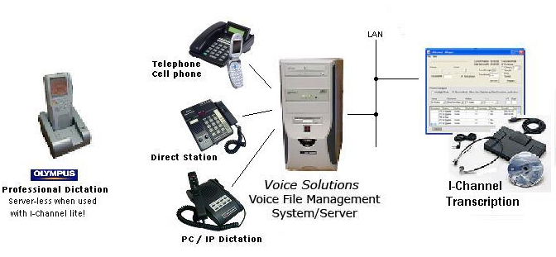
Proudly offering Voice Solutions Systems
“Keep it Simple, Make it Work!”


With cassette units going away fast, let our many years experience put a
Voice Solutions Digital System to work for you!

iChannel Lite
With file manager
770-393-9056
sales@deca-amr.com

