

Dictation Solutions for the Corporate market

Cost Effective Dictation Systems and Voice Capture

- Dictation Quickly and accurately communicate, to put
- Transcription Players your thoughts into action. Use telephones,
- Dial-in Voice Servers cellular, portable, or direct wired stations.
- Digital Handhelds

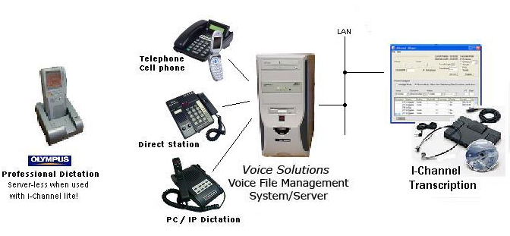
Proudly offering Voice Solutions Systems
“Keep it Simple, Make it Work!”
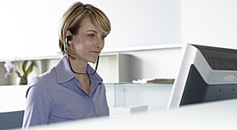

With cassette units going away fast, let our many years experience put a
Voice Solutions Digital System to work for you!

iChannel Lite
With file manager
770-393-9056
sales@deca-amr.com

